Experiment No. 3
Testing IoT Device Security (Default Passwords & Open Ports)

Run the docker command in command prompt
docker run -d -p 8090:3000 --name juiceshop bkimminich/juice-shop
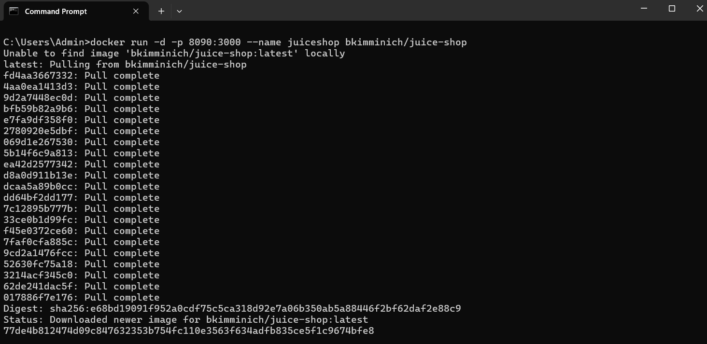

On Windows: ipconfig 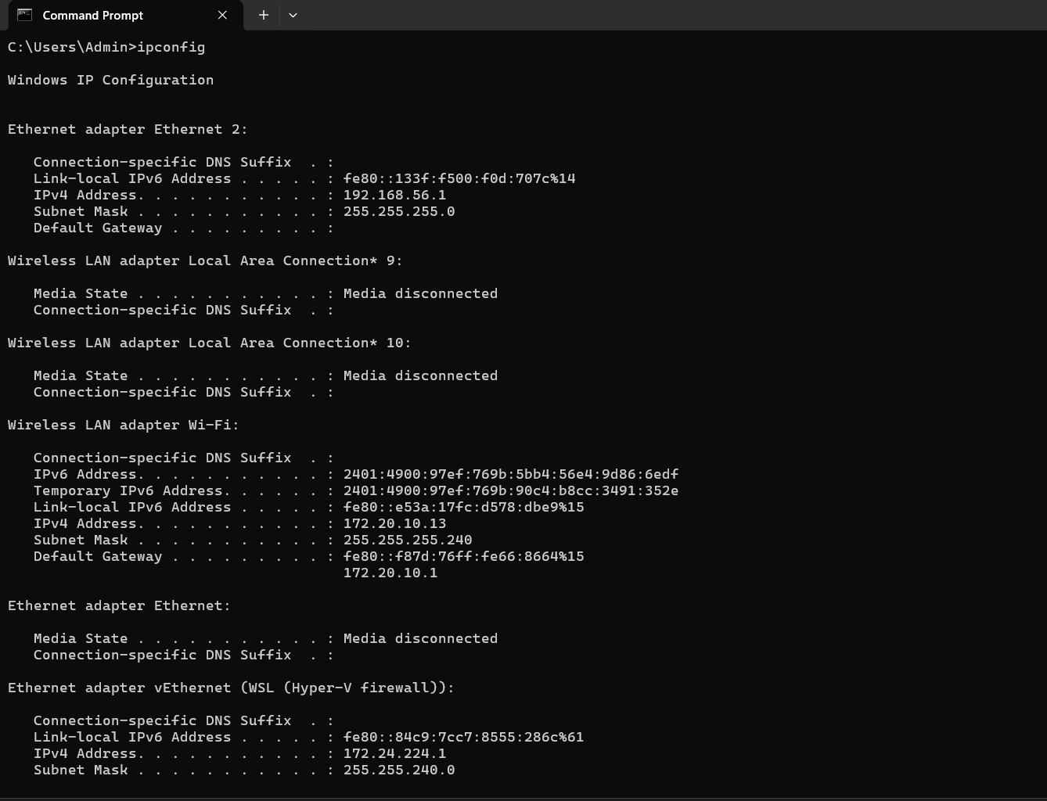

Step 3: Perform Network Scan from Kali Linux
nmap localhost
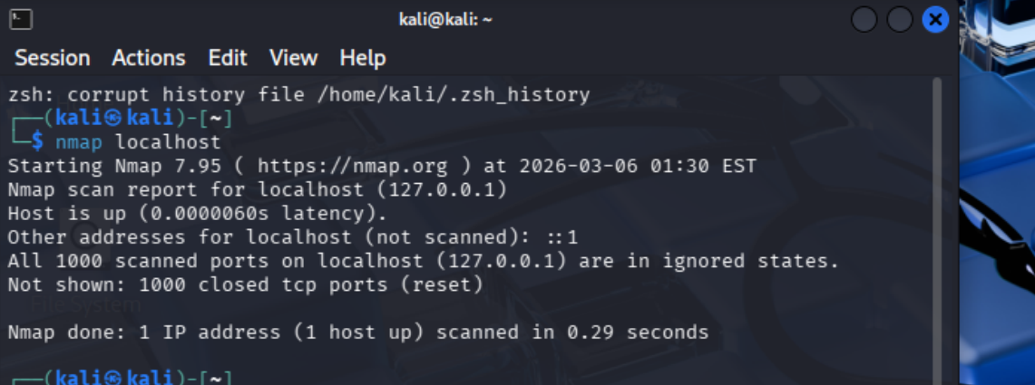
nmap –sV < ipaddress >
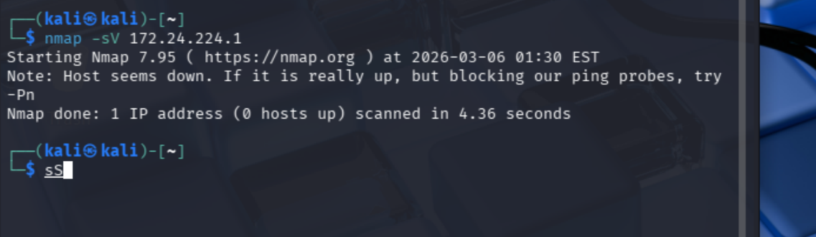

Navigate to http://localhost:8090 on windows
Juice shoup will be automatically open with adminstrator credentials
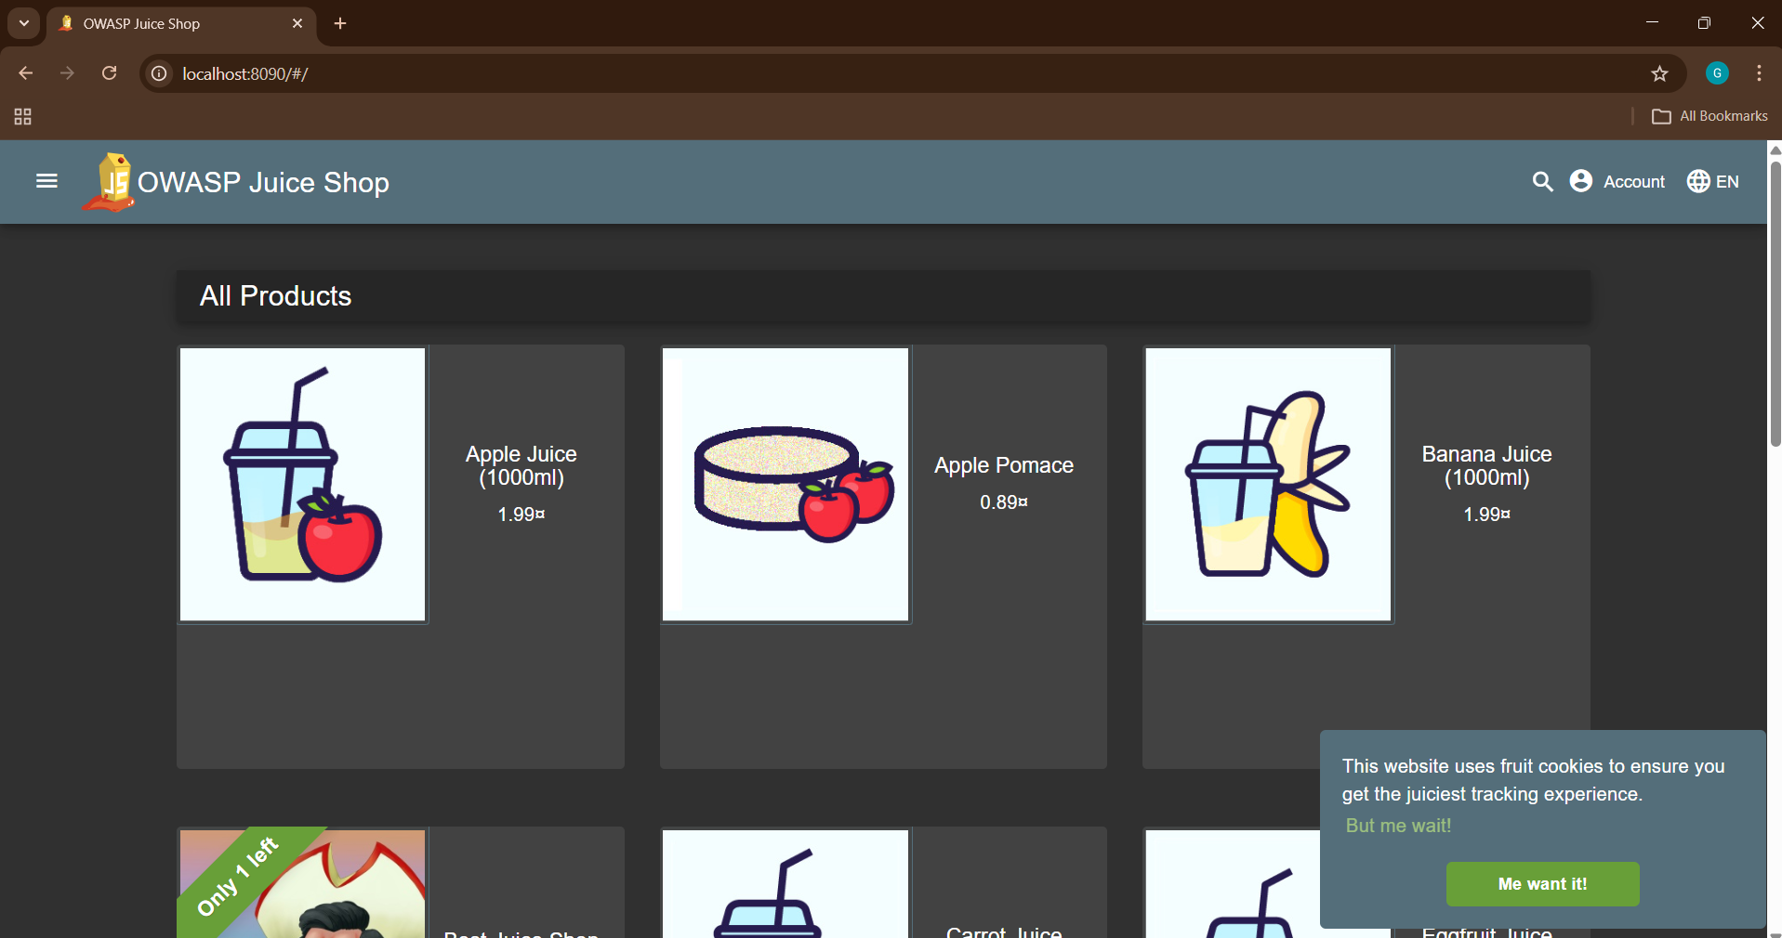

Inspect the website -> Go to Network settings -> select Fetch/XHR
